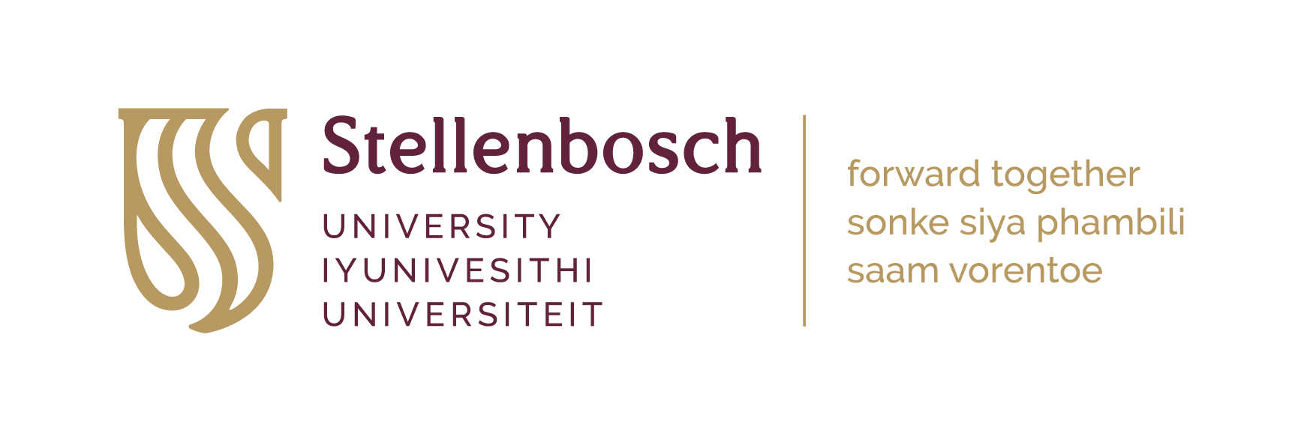
Willem Punt Bursary Fund
Application form

Please read the Terms and Conditions before completing this form in typescript, to ensure that you adhere to all the requirements. Incomplete, hand-written applications are not considered.

The Willem Punt Bursary Fund aims to support Stellenbosch University students or past students from their second year of study and beyond, in Afrikaans and/or Dutch, Theology, Law, Architecture and/or Visual Arts to study full-time at a Dutch University or School in any field related to the study of Dutch culture -or language -or related fields.

Section 1: Applicant Data
Surname |  |  |  |  |  | Title
First name(s)
SU Student number
Faculty
Department
Research Area/Speciality
Telephone |  |  |  | Fax
Email |  |  |  | Cell

Section 2: Details of Studies at the Dutch Institution
Dutch institution
Name of Degree Programme
Discipline or Field of Study
Anticipated departure date
Anticipated return date

Section 3: Details of SU Supervisor
Title, Surname (i.e. Professor Xhosa)
First Name(s)
Email
Department

Section 4: Please elaborate on the purpose of the visit, and outline of the intended research/studies to be conducted at the Dutch institution (Max. 500 words)

Please ensure that you attach the following documents
Curriculum Vitae
Academic Transcript
Detailed Budget for the trip, outlining the relevant costs and alternative sources of funding
Quotations / or Invoices

PART 7: SIGNATURE
SIGNATURE OF APPLICANT | DATE

